## **Group Project Document – Part 4**

## **Grocery Store Chain Database**

* **Project Part 04**
* **Team Number 02**
* **Team Members:**
  + Fuad Hassan
  + Omar Shakir
  + Tony Siu
  + Heron Ziegel
* **Database System Name:** **Grocery Store Chain Database**

**Part 1:**

## Requirements:

* Each **Employee** has a EmployeeID (unique), a FirstName and a LastName.
* Each **Customer** has a CustomerID (unique), a FirstName and a LastName.
* Each **Item** has a ItemID (unique), Price, Description.
* Each **Order** has a unique OrderID, a PurchaseDate, and may have a TimeCompleted or might not be completed yet. Each Order also has a TotalPrice, which is calculated based on the price of every Item in that Order.
* Each **Store** has a unique StoreID, and an Address made up of a Street, City, State and ZipCode.
* Each Employee works at exactly one Store, but each Store has at least one and can have many Employees.
* Each Order contains multiple Items and at least one, and each Item can be in multiple Orders or none.
* Each Employee processes zero or more orders. And Each Order much be processed by one Employee.
* Each Customer can have multiple Orders but doesn’t need to have any Orders. Each Order belongs to exactly one Customer.
* Each Customer can visit many stores and must visit at least one. Each Store can have multiple customers or at least one.
* Each Order is created at exactly one Store, and each Store has anywhere from no Orders to many.

## **ER diagram –** : Grocery Store Chain Database

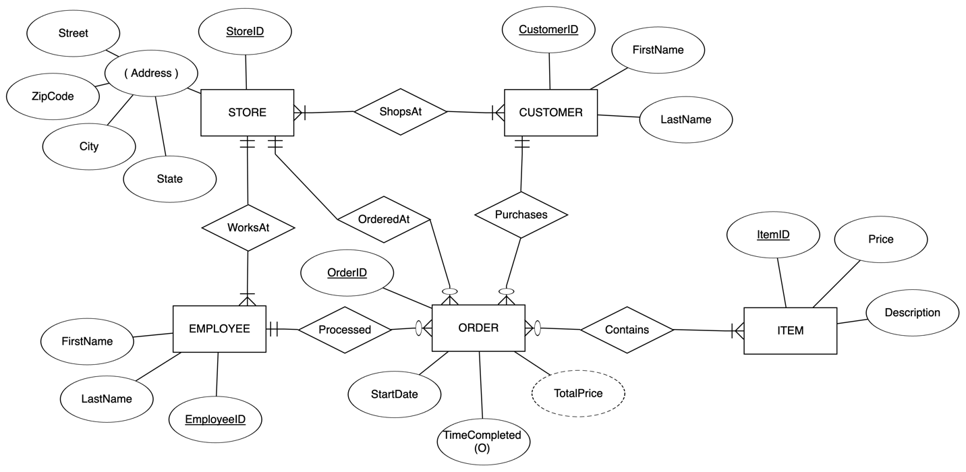

**Relational schema diagram** -: Grocery Store Chain Database

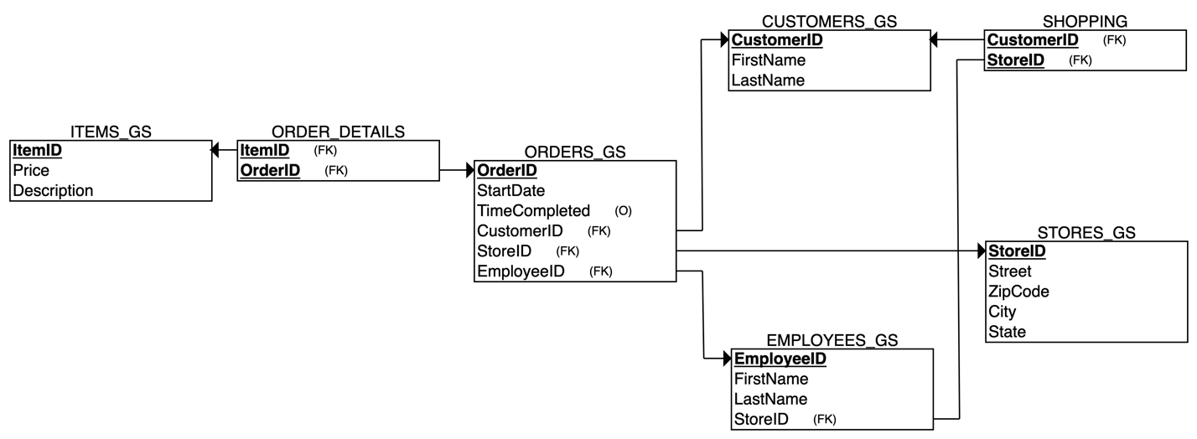

**Tasks Distribution** -: Grocery Store Chain Database

|  |  |
| --- | --- |
| Task | Name |
| Requirement | Heron, and 3 of us reviewed and edited |
| ERD | Heron, Fuad, Tony, Omar |
| Schema | We all did it together |
| SQL | Fuad, Omar, Tony |
| Presentation | Omar, and 3 of us |
| Summation and writing | Fuad |